**CREATING A NEW JAVA PROJECT**

**Open the NetBeans software**

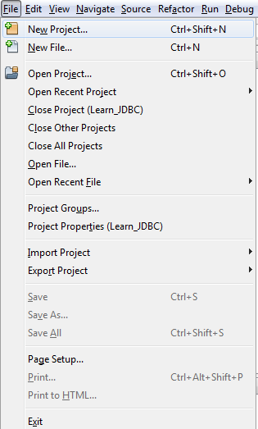

File Menu

--- New Project

**Categories : Java**

**Projects : Java Application**

**Click: Next**

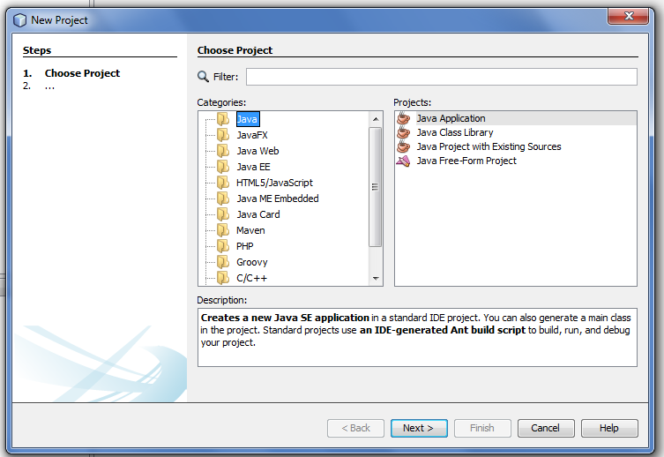

**Project Name: <Learn_JDBC>**

**Project Location : <browse and choose the desired location to save**

**the project in>**

**Click: Finish**

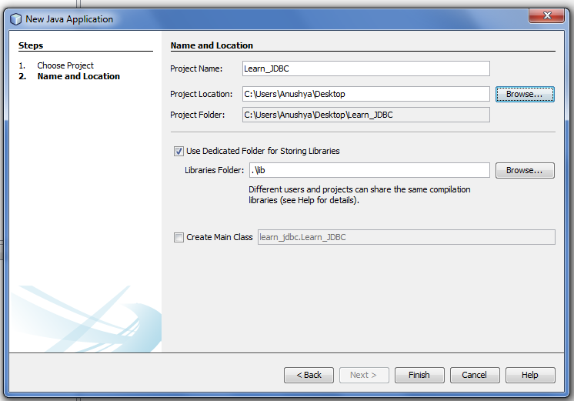

**A new project with the specified name would be created.**

**You can see the details in the Project Window**

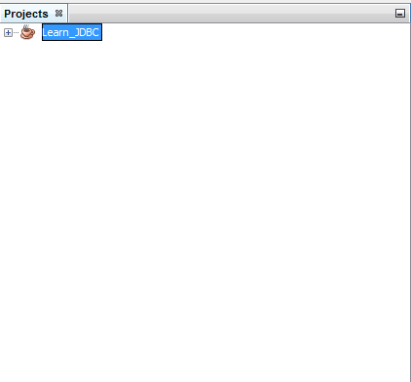

**Adding the JAR File: derbyclient.jar**

derbyclient Jar File should be included in the project if you are planning to use the Apache Derby database for your background operations such as creating tables.

Include the derbyclient.Jar file in the Project.

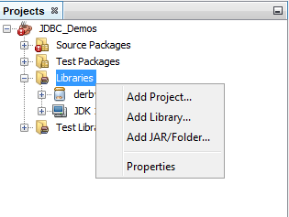

This Jar file is included in the JDK itself.

Path: C:\Program Files\Java\jdk1.8.0_71\db\lib\derbyclient.jar

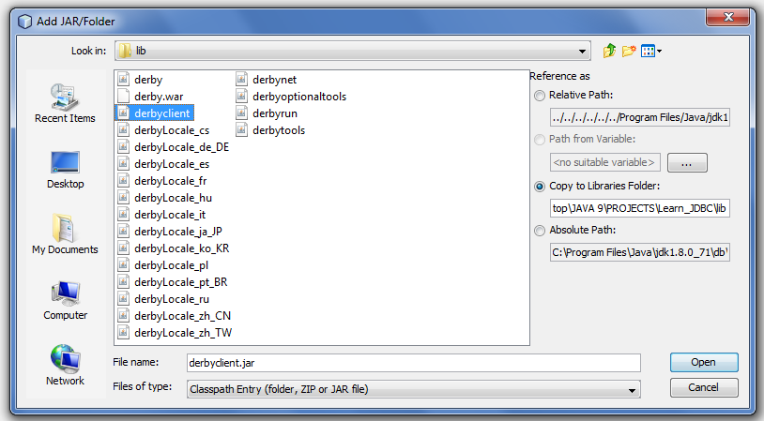

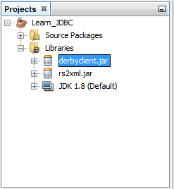

JavaDB

Right Click –Start Server

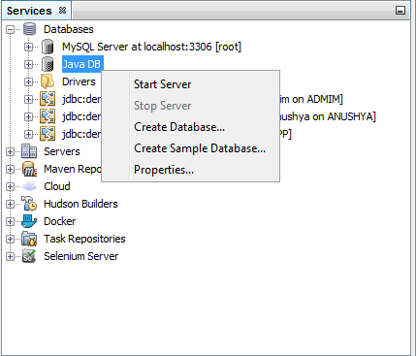

A message will be displayed in the output window – “….. started and ready to accept connections …..”



JavaDB

Right Click – Create Database

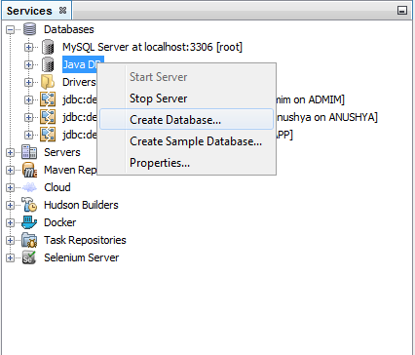

Create Java DB Window opens:

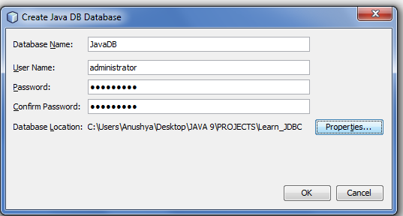

|  |  |
| --- | --- |
| Databasw Name | JavaDB |
| User Name | administrator |
| Password | jaisairam |

Database created successfully and the Connection String is now visible.

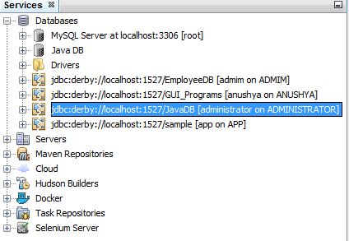

Right Click on the connection String

Select Connect

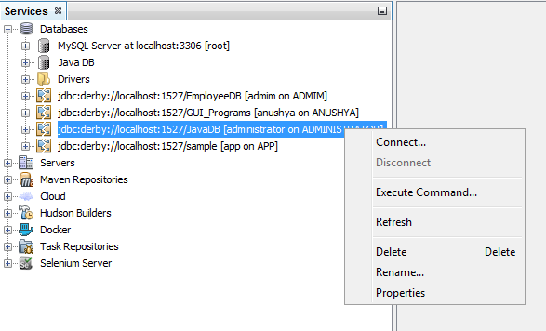

Now the Connection String will be ready and we can create Tables with the JavaDB Database.

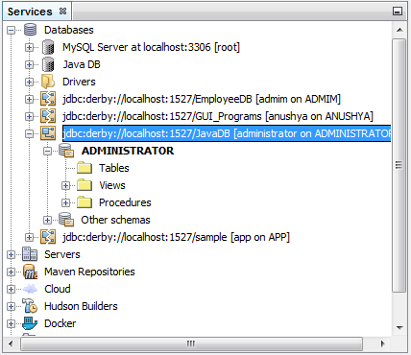

Expand the Connection String

A Schema with the User Name given while creating the DB would have been created.

Expand the Schema

You can see the Tables option.

Right Click on the Tables

Select – Create Table…

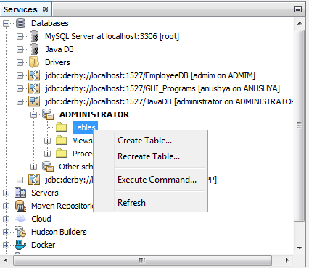

Create table dialog box opens:

Table Name: EmployeeDB

Click – Add Columns

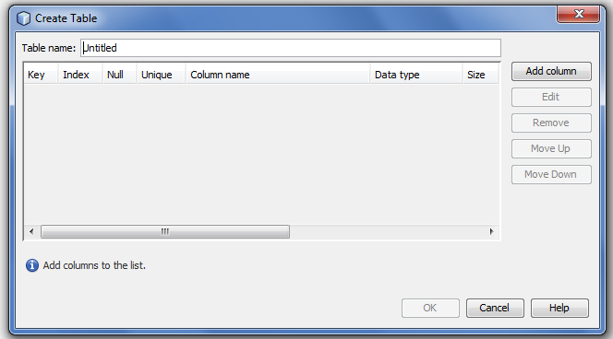

Give the Column

Name

Type <data type>

Size <If required – for Varchar>

Any Constraints

Click : Ok

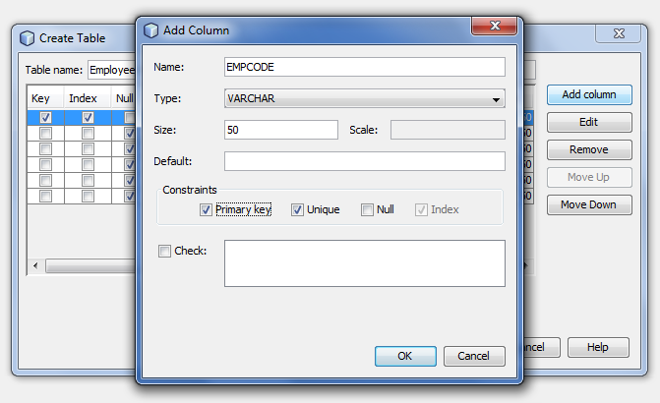

|  |
| --- |
| Columns |
| EMPCODE varchar(50) PRIMARY KEY |
| NAME varchar(50) |
| MOBILENO varchar(50) |
| EMAILID varchar(50) |
| USERID varchar(50) |
| PASSWORD varchar(50) |

Add the columns required one by one and after completing, Click - Ok

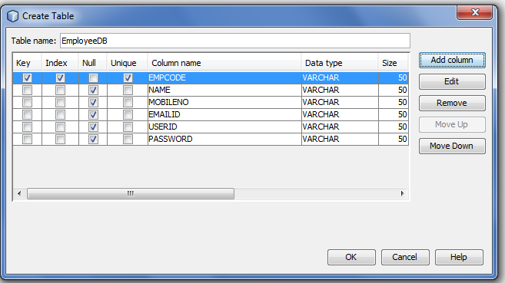

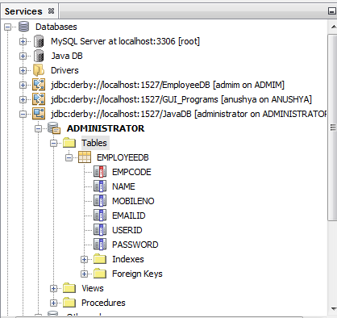

Table Created

**INSERTING DATA IN TO THE TABLE**

Data can be inserted in to the table using the Query Window (or) the UI

QUERY WINDOW:

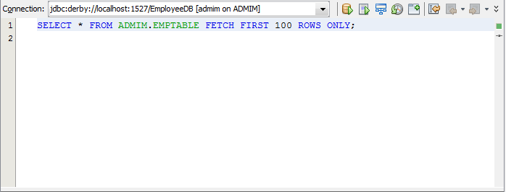

USER INTERFACE:

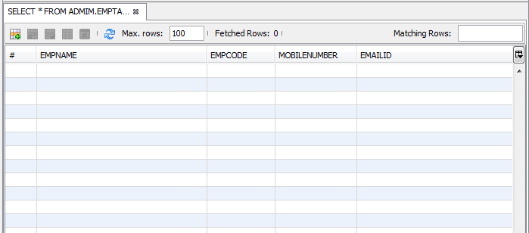

SELECT THE INSERT RECORDS OPTION -

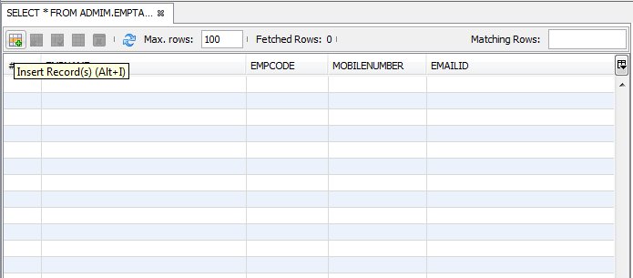

INSERT RECORDS POP-UP WINDOW WILL OPEN

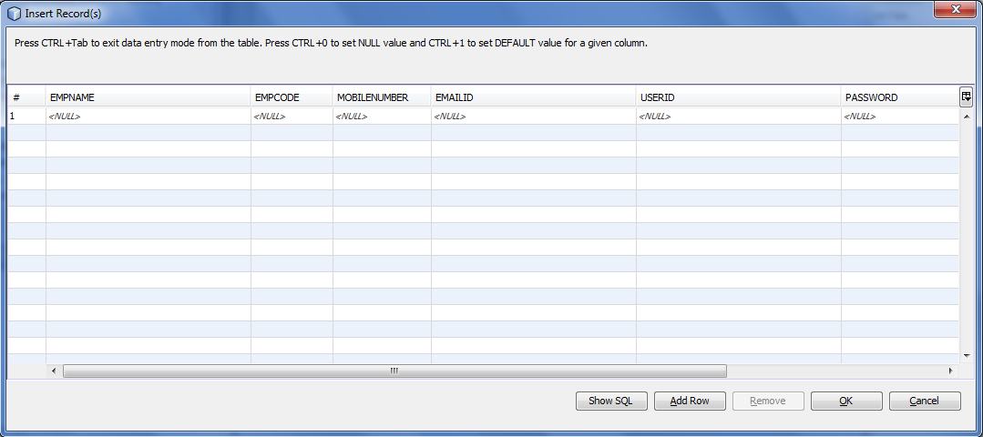

Fill the Employee details

To add another Record – Click: Add Row and enter the details

Once completed entering all the Records, Click: Ok

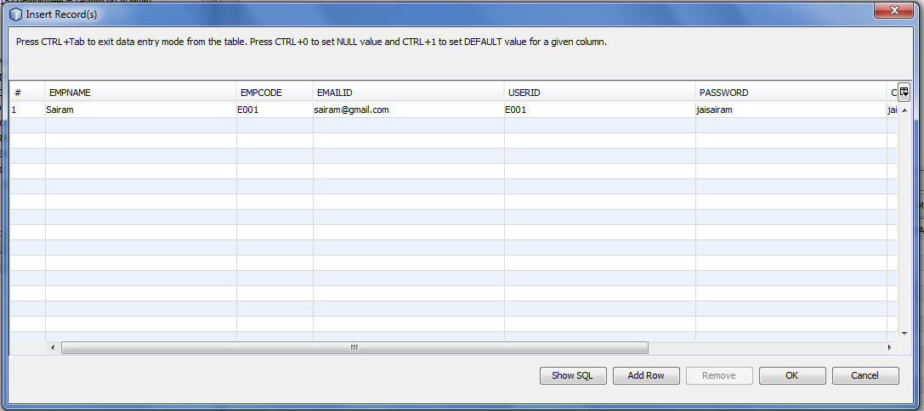

Once all the Records are entered, the table will look like this:

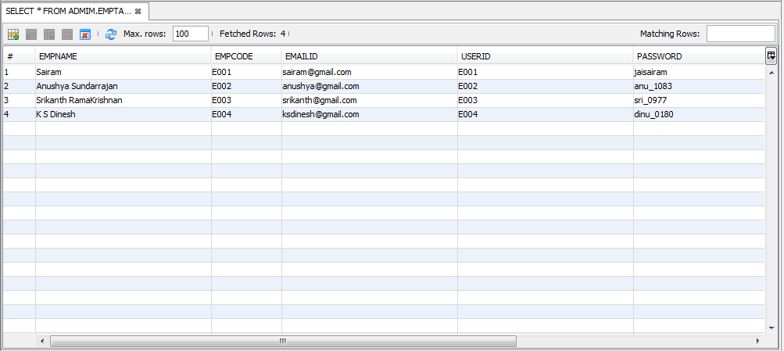

**USING THE QUERY WINDOW:**

Type the query and execute to view the output.

